Project Management
Final Exam Study Notes
Simplified & Easy to Understand

Introduction

Definition of Project Management
Project management started in the early 1950s, but its roots go back to the late 1800s. Businesses realized they needed a better way to organize work across different departments and teams. One of the first big uses of project management was in the US space programme.
General Definition: Project management is the process of planning, organizing, leading, and controlling resources to reach specific goals.
PMI (2004): Applying knowledge, skills, tools and techniques to project activities to meet project requirements.
Chase & Aquilano: Planning, directing and controlling resources (people, equipment, material) to meet technical, cost and time constraints.
Project management is often shown as a triangle with three key factors — Time, Cost, and Scope — called the Triple Constraint. Quality stays in the center.
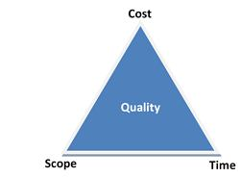
Figure 1: The Triple Constraint
- Projects must be within cost.
- Projects must be delivered on time.
- Projects must be within scope.
- Projects must meet customer quality requirements.

A newer version of this is the Project Management Diamond, which has four corners: Cost, Time, Scope, and Quality — with Customer Expectations at the center. Every customer is different, so you must understand what they expect.
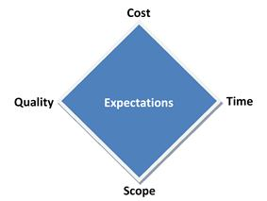
Figure 2: The Project Management Diamond

Functions of Project Management
No matter what type of project, project management always follows the same basic steps:

1. Defining the Project
The project manager figures out what the project is and what the users want to achieve. A list of deliverables (outputs) is made, and the manager works with sponsors, managers, and other stakeholders (people with interest in the project).
2. Planning the Project
All tasks and activities are listed, including how long each will take and how they connect to each other. The manager sets milestones (important checkpoints) and deadlines.
3. Executing the Project
The team is built, budget is assigned, and actual work begins. The manager knows how many resources and how much money is available.
4. Controlling the Project
The manager tracks progress by updating project plans with the actual time each task took. This helps understand how well the overall project is going.
5. Closure of the Project
The project manager, business owner, and stakeholders come together to review the final outcome and learn from the experience.

Importance of Project Management
Project management is very important for an organization's success. It helps with growth, handling challenges, and improving overall performance.
- Ensures High Product Quality: Good planning, budgeting, and quality control help produce better products, which makes customers happy.
- Promotes Effective Communication: Project managers connect team members and stakeholders to ensure clear and timely updates.
- Reduces Risks: Problems and risks are identified early so they can be prevented before they cause damage.
- Supports Strategic Goals: Project activities are aligned with organizational goals to make better decisions.
- Improves Crisis Management: Unexpected challenges like financial problems or disasters are handled through proper planning.
- Enhances Resource Utilization: People, materials, and money are used wisely, reducing waste and improving productivity.
- Ensures Timely Completion: Tools like scheduling, Gantt charts, and performance tracking help finish projects on time.

In short, project management helps organizations complete projects on time, use resources well, and achieve long-term success.

Project Formulation

Concept of Project Formulation
Project formulation means turning a project idea into a clear, step-by-step plan that helps decide whether to invest in it or not. It controls how much money is spent on developing the project before it is officially started.
B.B. Goel: Project formulation is a series of steps that converts an idea or aspiration into a workable plan of action.
G. Myrdal: Project formulation is a basic technique that changes planning from just an idea into a rational and institutional base.
Project formulation needs a team of experts working together. Each member must understand the overall strategy and objectives. A well-prepared feasibility report helps everyone — scientists, social workers, and policymakers — work together toward a common goal.
For a large project, the team should include:
- One industrial economist
- One market analyst
- One or more engineers/technologists for the specific industry
- One mechanical or industrial engineer
- One management accounting expert

Stages of Project Formulation
1. Project Identification
This step involves collecting and analyzing economic data to find possible investment opportunities and understand their characteristics.
2. Technical Analysis
Technical analysis includes input analysis covering the following aspects:
- Site: Location of the enterprise, whether land is owned or leased, and approval from local authorities.
- Raw Material: What raw materials are needed and where they will come from (local or imported).
- Human Resource: Availability of skilled and semi-skilled workers, and training arrangements.
- Technology Selected: Which technology will be used and how it will be obtained.
- Utilities: Power, fuel (coal, oil, gas), and water requirements and availability.
- Pollution Control: How waste and sewage will be managed.
- Communication System: Availability of telephone, fax, internet, etc.
- Transport Facilities: Transport needs, modes, distances, and any transportation problems.
- Other Common Facilities: Machine shops, welding shops, electrical repair shops, etc.
- Production Process: Steps involved in converting raw materials into finished goods.
- Machinery and Equipment: Complete list of machines with their size, type, cost, and sources.
- Capacity of the Plant: How much the plant can produce including working shifts.
- Research and Development: Future R&D activities that are planned.

2. Demand and Supply Analysis
This step involves finding out how much demand exists for the product and how much is currently being supplied. The gap between demand and supply shows the opportunity for the new project.
Ways to measure demand:
- Survey of buyer intentions
- Composite of sales force opinion
- Expert opinion
- Market test method
- Statistical method

3. Feasibility Study
A feasibility study objectively identifies the strengths, weaknesses, opportunities, and threats of the project. It also shows the resources needed and the chances of success.

4. Project Appraisal
Project appraisal is a review of all aspects of the project to see if it will meet its goals.
B.B. Goel: It is a tool to check whether committing resources to the project is realistic and reasonable.
P.K. Motto: It is the process of evaluating feasibility, technical, financial, and social aspects of a project.
The following aspects must be covered in project appraisal:
- Technical Viability: Can the project be built and operated technically?
- Commercial Viability: Is there enough market demand?
- Financial Viability: Will the project make enough profit?
- Economic Viability: Will it benefit the national economy?
- Environmental Viability: Can all environmental requirements be met?
- Managerial Viability: Is the team capable of managing the project efficiently?

Project Plan

Definition of Project Plan
Project planning is a step-in project management where all necessary documents are created to ensure how the project will be completed successfully. It defines how the project will be executed, monitored, controlled, and closed.
Simple definition: A Project Plan shows the phases, activities, tasks, timeframes, resources, and milestones needed to deliver to a project.
PMBOK: A project plan is a formal, approved document used to guide project execution and control. It documents planning decisions, scope, cost, and schedule baselines.
R.L. Martino: A project plan establishes how long the project will take, what resources are needed, and the correct order of activities.
Project planning requires analysis and structuring of these key activities:
- Setting up project goals
- Identifying project deliverables
- Creating project schedules
- Creating supporting plans

Steps of Project Planning
Project planning is the most important part of project management. It gives direction for successful execution.
1. Project Goals
Identify all stakeholders (sponsors, customers, users, team members). Gather their needs through interviews, prioritize them, and set clear measurable (SMART) goals.
2. Project Deliverables
Based on the goals, list all outputs the project must be produce. Define what will be delivered, when, and in what form, with estimated deadlines.
3. Project Schedule
Break deliverables into tasks. Estimate the time, effort, and resources needed. Assign responsibilities and set realistic deadlines.
4. Supporting Plans
a. Human Resource Plan: Define team members, their roles, responsibilities, and the number of people needed.
b. Communication Plan: Decide how project information will be shared with stakeholders through reports, meetings, or updates.
c. Risk Management Plan: Identify possible risks, prepare preventive actions, and create backup plans.
A good project plan ensures clear goals, smart use of resources, proper communication, and risk control — all leading to successful completion.

Importance of Project Planning
Project planning is essential before starting any project. Without proper planning, projects can be easily failed due to confusion and lack of structure.
- Reducing Risk: Planning helps to finds potential problems early so that they can be avoided before becoming serious.
- Reducing Uncertainty: Planning improves understanding of the project, technology, and team so that the team builds the right thing.
- Better Decision Making: Accurate estimates of cost, time, and resources help decide if a project is worthwhile.
- Building Trust: Good planning and reliable delivery build trust between the project team and clients.
- Effective Communication: A project plan clearly shows goals, expectations, and timelines to all stakeholders.

A flexible and well-structured plan greatly increases the chances of project success.

Project Schedule

Definition of Scheduling
In project management, a schedule is a list of all project activities with their planned start and finish dates. These activities are the smallest tasks that cannot be broken down further. They are estimated in terms of resources, budget, and duration.
A schedule converts the project action plan into an operating time-table. It is the foundation for monitoring and controlling project activities along with the plan and budget.

Scheduling means deciding how much time each task needs and in what order the tasks should be done to meet the project's goals.

Network Techniques (Critical Path Method — CPM)
CPM was developed in the 1950s by DuPont for chemical plants (1957).
James E. Kelley & Morgan R. Walker: CPM is a method of planning, scheduling, and controlling projects by placing activities in a network diagram to find the longest sequence of dependent tasks (the critical path) that controls the total project duration.
Keith Lockyer: Network techniques are systematic methods of planning and controlling projects by breaking them into activities, showing their sequence in a network diagram.

In CPM, activities are shown as nodes (circle) on the network. Events that mark the start or end of activities are shown as arcs or lines between the nodes.

Figure: CPM Diagram

Arrow and Node Diagram
The following table shows the activities and their immediate predecessors:

Activity | Immediate Predecessor Activity
A | -
B | -
C | A
D | B
E | B
F | C
G | D and E

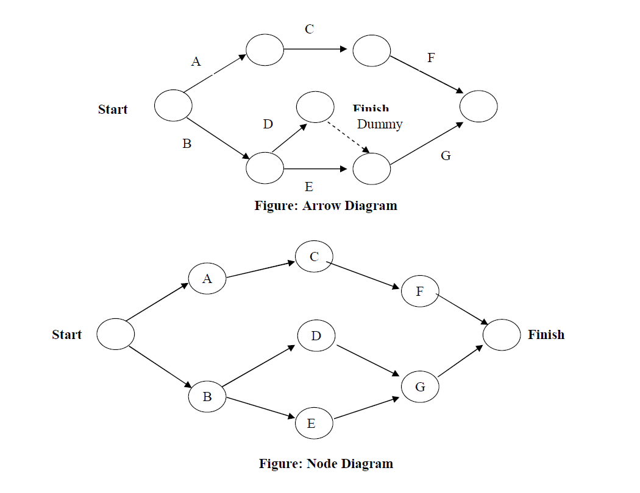
Note: Arrow Diagram and Node Diagram are two ways to draw the same network. In the Arrow Diagram, activities are shown on arrows. In the Node Diagram, activities are shown inside boxes (nodes).

Critical Path Example
The following information is for a construction project. Use the data to draw a network diagram and find the critical path.

Activity | Time (weeks) | Immediate Predecessor
A | 6 | -
B | 9 | A
C | 8 | A
D | 12 | A
E | 11 | B
F | 7 | C, D
G | 12 | E, F
H | 14 | D
I | 9 | G, H

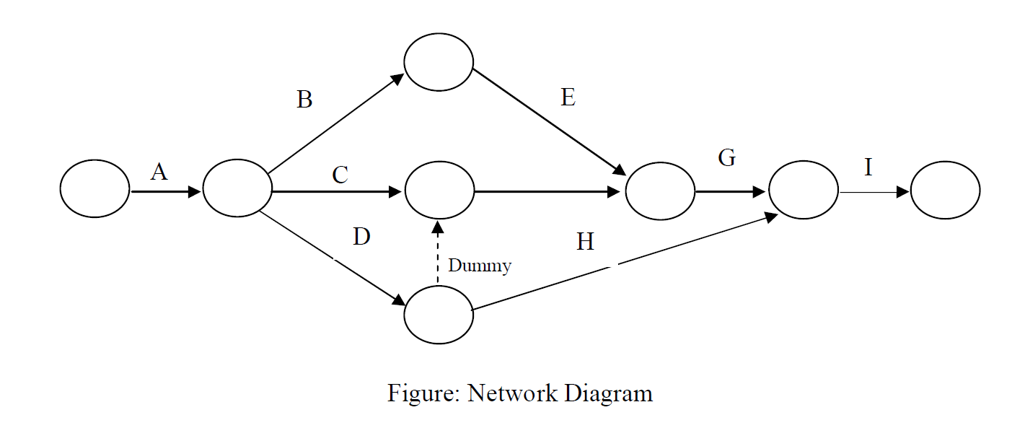
F

Determination of Critical Path
To find the critical path, we calculate all possible paths from Start to Finish and find the longest one:

A – B – E – G – I = 6 + 9 + 11 + 12 + 9 = 47 weeks
A – C – F – G – I = 6 + 8 + 7 + 12 + 9 = 42 weeks
A – D – Dummy – F – G – I = 6 + 12 + 0 + 7 + 12 + 9 = 46 weeks
A – D – H – I = 6 + 12 + 14 + 9 = 41 weeks

The longest path is A – B – E – G – I with 47 weeks. This is the Critical Path. The critical path is the longest path — it controls the total project duration. Any delay in a critical path activity will delay the whole project.
∴ Critical Path = A – B – E – G – I = 47 weeks

Project Implementation

Concept of Project Implementation
Implementation is the stage where all planned activities are actually carried out. Before starting, the implementors (led by the project committee) should look at their strengths and weaknesses and opportunities and threats. Strengths and opportunities should be used well. Weaknesses and threats must be overcome.
Harold Kerzner: Project implementation is the stage where project plans are put into action and work is carried out to achieve desired results.
Dennis Lock: Project implementation is the stage where all planned activities are executed, monitored, and controlled to achieve project objectives.
In simple words: implementation is the action that must follow all the planning and thinking so that something actually happens.

Steps of Project Implementation
Project implementation is a structured process for effective communication, coordination, and successful project completion.
1. Seek Guidance:
A project manager should get advice from experienced professionals, especially if they are new to project management.
2. Acquire Tools and Software:
Proper tools like computers, communication systems, and project management software must be set up to support smooth implementation.
3. Clarify Project Details:
The project plan must clearly state the objectives, timeline, budget, team members, methods, and risk strategies.
4. Assign Responsibilities:
Roles and duties of all team members should be clearly defined, and communication channels must be set up.
5. Monitor Progress:
Project performance, quality, time, and cost should be checked regularly to ensure the project stays on track.
6. Document Information:
All activities, progress reports, decisions, and problems must be properly recorded for future reference.
7. Communicate with Stakeholders:
Regular communication with upper management and clients is essential to keep them informed about project progress.

Following these steps helps ensure effective project implementation and increases the chances of project success.

Impediments to Project Implementation & Strategies to Overcome Them
Successful project implementation often faces several obstacles that can cause delays, increase costs, or reduce quality. These usually come from managerial, technical, financial, and environmental factors.
1. Poor Planning and Unclear Objectives
Weak planning or unclear goals cause confusion among team members, leading to inefficiency and delays.
Strategy: Use tools like Work Breakdown Structure (WBS), set SMART objectives, and create detailed schedules from the very beginning.

2. Lack of Adequate Resources
Projects fail when there are not enough people, money, materials, or technology.
Strategy: Do proper resource planning during the initiation phase, ensure realistic budgeting, and use resource leveling techniques.

3. Poor Communication
Ineffective communication between managers, team members, and stakeholders leads to errors, misunderstandings, and delays.
Strategy: Create a strong communication plan, hold regular meetings, send progress reports, and use project management software.

4. Risk and Uncertainty
Unexpected events like market changes, technical failures, political instability, or natural disasters can disrupt project work.
Strategy: Practice risk management — identify risks, assess them, and create mitigation and contingency plans in advance.

5. Lack of Skilled Workforce
If team members lack the necessary technical or managerial skills, the project will suffer.
Strategy: Invest in training programs, hire experienced professionals, and provide continuous skill development opportunities.

Executive Committee of National Economic Council (ECNEC)
ECNEC is a powerful committee that implements the policies decided by the National Economic Council (NEC). It is the main authority responsible for approving development projects. ECNEC also reviews reports from the Implementation, Monitoring and Evaluation Department (IMED).
The Prime Minister is the head (chairperson) of ECNEC. Members include the Ministers of Industry, Commerce, Finance, Labor, and the ministry that initiates the project.
The following people must be present at ECNEC meetings:
- Secretary of the Ministry
- Members of Planning Commission
- Members (General Economic Department) of Planning Commission
- Members (Related Department) of Planning Commission
- Governor of Bangladesh Bank
- Secretary of External Resources Development (ERD)
- Secretary of Finance Department
- Secretary of Planning Department
- Secretary of Implementation, Monitoring and Evaluation Department (IMED)
- Secretary of the Related Ministry
- Chief of Armed Forces

Problems of Project Management in Bangladesh
A project's success depends on proper planning, efficiency, cooperation, timely approvals, regular monitoring, and adequate resources. However, in Bangladesh, many of these elements are missing, leading to delays and cost overruns.
1. Crowding of Projects
Too many projects are added to the Annual Development Programme (ADP) due to political promises. The government does not have enough resources to complete all of them within one financial year. This leads to delays and increased costs.
2. Over Dependence on Foreign Aid
Many projects rely on promises from donor countries or organizations. In practice, donors often fail to provide funds as promised, causing the project to slow down or stop.
3. Lack of Objectivity
Many experts point out that projects in Bangladesh often lack clear and specific objectives. Without proper goals, projects cannot reach their intended targets.
4. Lack of Proper Coordination and Cooperation
Many ministries and agencies are involved in approving and implementing projects. Lack of cooperation and coordination among them causes delays and increased costs.
5. Delay in Approval of Projects
There are multiple authorities (ECNEC, PEC, SPEC, DPEC, SDPEC) for approving projects. The approval process has many stages and takes a long time. By the time approval is given, the starting time may have already passed and donors may have lost interest.
6. Inadequacy of Resources
Over-dependence on foreign aid, too many projects in ADP, and corruption make it difficult to use resources properly. Internal funding is often insufficient.
7. Lack of Constant Monitoring & Evaluation
IMED under the Planning Ministry is responsible for monitoring. However, it is not possible to monitor all projects at once. Only selected projects are evaluated, meaning many development projects go unchecked.
8. Absence of Sound Plan & Political System
Realistic planning and political stability are essential for proper implementation. Bangladesh lacks a stable political environment, which creates obstacles for project implementation.
9. Conflict & Coordination Problems at Local Level
Decentralization of government power creates administrative and political problems. Local people often do not participate in planning, and local decision-makers sometimes lack professional skills.
10. Lack of Skilled Manpower and Sound Techniques
Shortage of skilled project directors and workers, absence of effective training systems, and lack of knowledge about modern project management technology are major obstacles.
11. Delay in Fund Release
Delay in releasing project funds is a very common problem in Bangladesh. It directly hinders effective and timely project implementation.

Steps for Improving Project Management in Bangladesh
1. Determine the Objective and Goal
Clear and specific objectives must be set for both short-term and long-term projects. The possibility of getting required national resources and foreign aid must be considered so that projects can be completed on time and within budget. Projects should be prioritized based on their importance.
2. Selection of Organizational Structure
A proper organizational structure must be selected for effective implementation. Duties and responsibilities must be divided clearly between upper and lower levels. Modern tools like CPM, PERT, CASPAR, and MIS should be used for scheduling and cost estimation.
3. Reduce Complexity and Long-Term Process
Project processing and approval should be made simpler and faster. Delayed approvals waste resources and miss implementation opportunities. Measures should be taken to prevent corruption and indiscipline.
4. Proper Coordination
Different government ministries and development organizations must work together. Proper coordination among all related parties is essential for smooth project implementation.
5. Ensure Local Participation
Local people must be involved in the project because they understand the local problems and needs best. Their participation makes project selection easier and ensures their support during implementation.
6. Reduce Complexity in Fund Release
The process for approving and releasing project funds should be simplified and made faster. Regular supply of funds helps ensure that project activities are completed within the fixed time.
7. Proper and Regular Monitoring
Regular and effective monitoring is necessary for successful project implementation. A central monitoring cell under IMED should be established at both division and district levels to make the process more efficient.
8. Training System
Project directors and managers must be properly trained. International or local specialists can provide the training. This will improve their technical, theoretical, and human management skills.

These are the key suggestions for improving project management in Bangladesh.

